Listing Checklist and Submission Form
The following items must be completed to get you listed without delays. Initial each line as you complete.
______ 1. The Listing Agreement must be read, completed fully, and signed. Make sure you indicate the commission to be offered to the buyer’s agent. This amount is a percentage of the contract purchase price. It cannot be zero, TBD, or a range. It has to be a number.
______ 2. The MLS Input Form. All REQUIRED items must be completed except agent section questions. Skip things like Area, VOW Include, List agent ID… We fill that in. Commonly missed items are Tax parcel id numbers (can be found on your tax bill), Schools (can be found by calling your school board), Square footage and room dimensions (only required in Greenville MLS). These can be measured with a tape measure. Lastly, in the checkbox section please do not make your own boxes as we can’t add them.
______ 3. Remarks or the written description of your home needs to be emailed in the body of an email or as a word document. Your MLS input form will indicate how many CHARACTERS you are allowed.
______ 4. Directions need to be emailed in the body of an email or as a word document. Your MLS input form will indicate how many CHARACTERS you are allowed.
______ 5. Seller’s Disclosure needs to be completed fully for all homes (not land).
______ 6. Lead Based Paint Disclosure only needs to be completed if your home was built IN or PRIOR to 1978. You must INITIAL both lines A and B and mark a check in the box that applies and sign at the bottom.
______ 7. PHOTOS: If you want your photos in a specific order you need to rename the pictures to 1,2,3, etc. This can be done by right clicking on the photo, select rename, and type; 1, 2, or 3…..
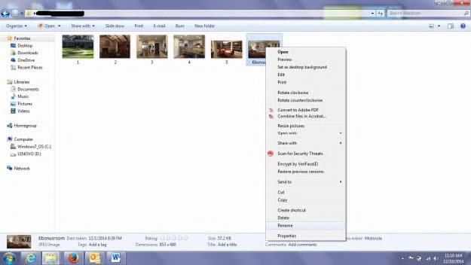
Please upload them to the web page here http://isaverealty.com/photo_upload.php
Please return this form when all have been completed and emailed to info@iSaveRealty.com

